**LinkedIn Top Skills Insights**

1. **First insight:**

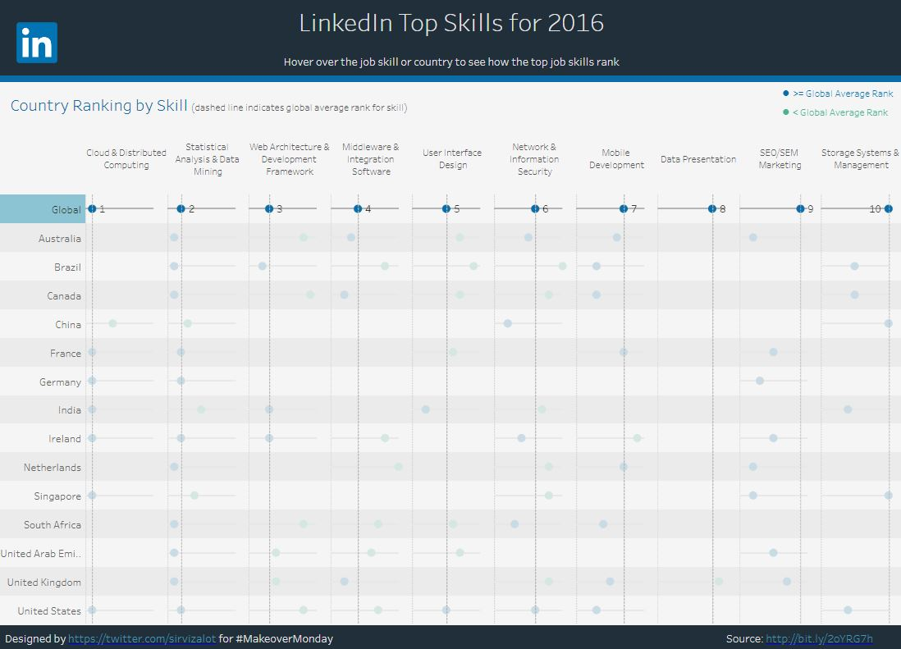

According to the chart of LinkedIn Top skills 2016 I've noticed after clicking on global averages that the highest are cloud & distributed computing, statical analysis & data mining, and web architecture & development framework. While the lowest averages of top skills are data presentation, SEO/SEM marketing, and storage system & management.

1. **Second insight:**

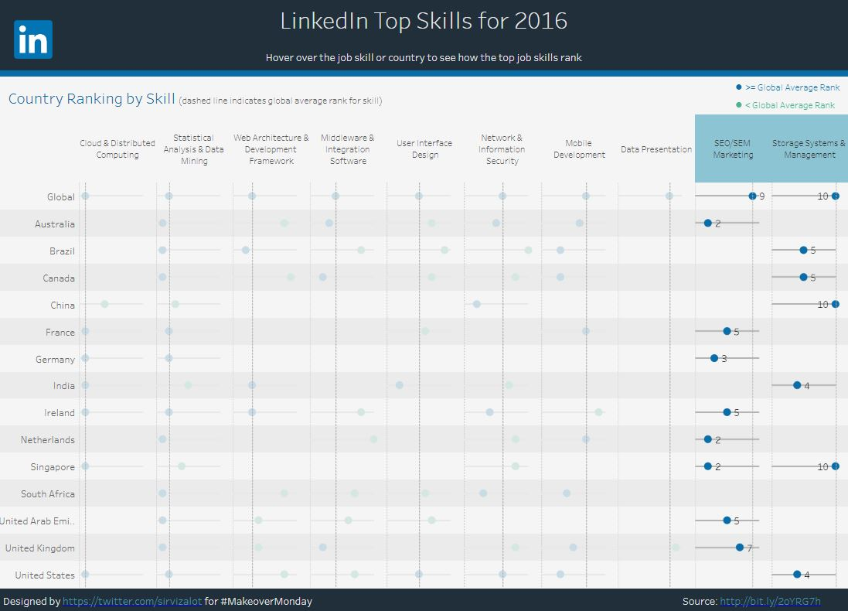

After selecting both of SEO/SEM marketing, and storage system & management skills averages on LinkedIn Top skills 2016 chart, it showed that both of them are all >= global average rank of all countries observed, according to the info in the top right of the chart where blue dots appear in all results.

1. **Third insight:**

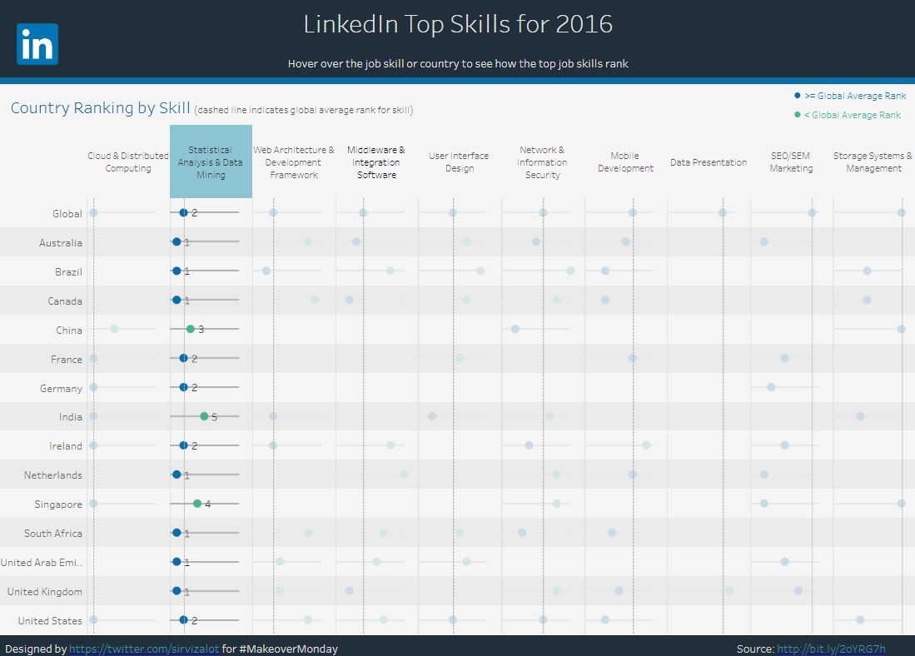

After examining LinkedIn Top skills 2016 chart and selecting Statical analysis & data mining skills, I've noticed that all 14 countries got analyzed and most of them have an average >= global rank except for China, India, and Singapore with < global average rank, according to the info in the top right of the chart where blue dots appear on most of them except for China, India, and Singapore with green dots.